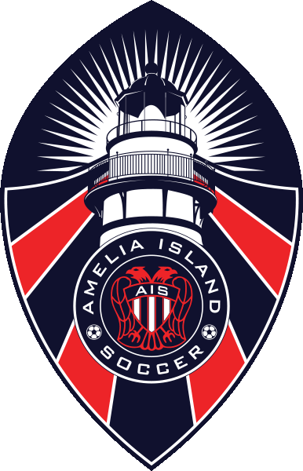

Thanks for volunteering, we have put together this handbook to help you get started. There are several thing you will need to do prior to you first practice and game. We have tried to make it easy by putting this step by step guide together. If you get lost you can always email one of the Board of Directors.

- TABLE OF CONTENTS
  - Board of Directors (BOD)
  - Background check & CDC Training
  - SafeSport Certification
  - Players Pass
  - Roster
  - Medical Release
  - Parent meeting draft
  - Practice info
  - Helpful information

Below is a list of the Board of Directors emails and phone numbers, in case you need to ask a question.
Position | Name | Email | Cell Number
President | Jay Denison | President@aiysoccer.com | (904) 206-2390
Vice President | William Dahn | VP@aiysoccer.com
Secretary | Ginny Foxworth | Secretary@aiysoccer.com
Treasurer | Stacy Hanna | Treasurer@aiysoccer.com
Registrar | Connie Denison | Registrar@aiysoccer.com
Director of Advanced Competition | Jay Denison | President@aiysoccer.com | (904) 206-2390
Director of Recreational | Aaron Opheim | DirofRecreational@aiysoccer.com | (904) 415-9065
Director of Referees | Mike Giannini | Assignor@aiysoccer.com
Director of Public Relations | Erin Joyce | Public_Relations@aiysoccer.com
Director of Coaching Academy | Andy Francis | Dir_of_Coaching@aiysoccer.com
Director of Volunteers | Josh Harrison | jj.harrison@Hotmail.com
Director of Facilities | Kenny Walczak | Walczakk@cloud.com
Director of Fund Raising | Dave Mumbauer | Dirfundraising@aiysoccer.com

This hand book was put together to help new coaches navigate their way through the admin side of coaching for AIYS. It is extremely important that you complete the following before the start of your first practice each year.
- Do your background check in gotsport
- Complete the center for disease control (CDC) test
- Complete the SafeSport certification

Once you have been selected as a coach for AIYS you will receive an email from Gotsport. Your email address is your ID. You will need to request a password reset to login for the first time. Follow these direction to complete all three requirements.
Step 1: Login to Gotsport.com https://system.gotsport.com
Step 2: Enter your email and password
Step 3: Click on Dashboard and then requirement, it will show you the three requirements.
Heads up
Background Check
Safe Sport

All coach (Head/Assistant coach) are requirements to have background check, CDC and Safesport completed Pryor to getting roster of players and or starting your first practice!
U6-U10 coaches: You are done once you get the certification in gotsport you can skip to page 7, Helpful Information.

**U11 and up coaches need the following: Because you will be playing team from other clubs.
- Player passes (laminated)
- Roster
- Medical release forms(signed by parents)

Player passes:
Visit www.gotsoccer.com and then follow direction on how to add player under coach management.

How to Print a Roster / Player Cards For An Event Roster – GotSport (zendesk.com)

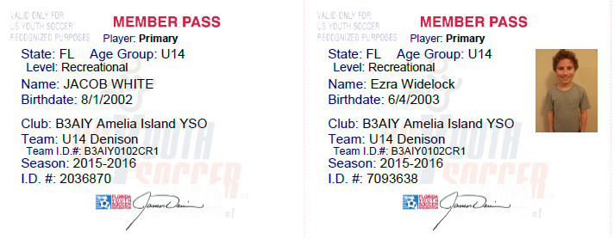
Bad Player ID Cards **missing picture Good Player ID Cards
The player pass on the left is missing the picture and this player is not qualified to play.

** There is a laminator in the concession stand just ask a board member and they will help you find it.

Rosters:

Visit www.gotsoccer.com and then follow direction on how to add player under coach management.

Printing Roster and Pass Cards as a Coach or Manager – GotSport (zendesk.com)

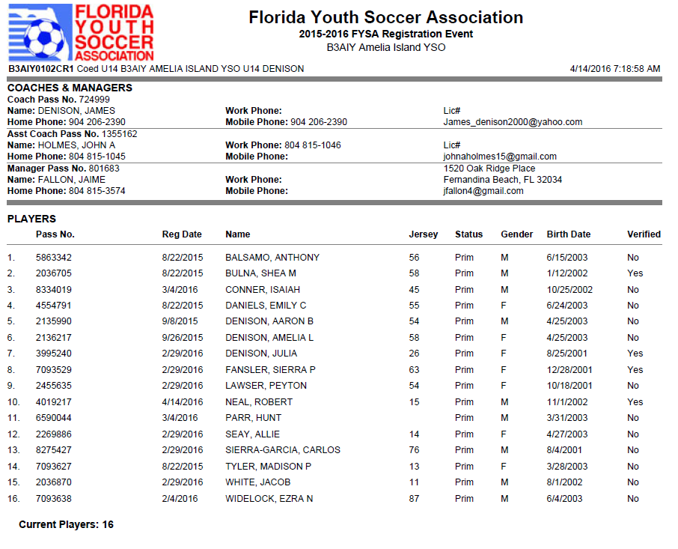
***All U11 and above coaches must have a copy of the “Official roster” and laminated copies of “player passes” at all games, (home and away). The club will be fined if you don’t have both during check-in process prior to game.

**If you do not see your name or your assistant coach's name on the official roster then we do not show you as having completed the background check or CDC Heads up Concussion video. If you have completed them, then please use your individual coach login to look it up and send the administrators at the emails noted above. To log into your coach account (after it has been created), you must log into gotsoccer, team/team officials/individual coach.

Helpful Information

Game Day Uniforms:
Red/Blue = home team
White/Blue = away team

Game change policy and Reporting Scores (U11 and up only) Click Here

Volunteer Hours
All Coaches and Team manager are exempt from volunteer hours. You have done your part already. We do need your help to remind the parents who didn’t buyout about volunteering 3 hours per player to the club. They can sign up using signup genius on website under parents tab and selecting your desired task and dates. The club tracks who volunteer and who does not and a $20 per hour charge will be added to your next season bill if you do not fulfill your volunteer hours.
Team Managers
U6-10, Help the coach out with snack schedule, who is not coming to games and the volunteer duties the parent should be doing. Help with end of season party or any other task you can take off the coach’s plate.
U12 and up: The Team manager should print two copies of player pass and roster. After you have print them take the player passes to the concession building at the fields and laminate them. Give one copy of player passes and roster to the head coach and keep a copy for back up and bring them to all games. Also keep a copy or them medical release and bring to all games. Got Soccer helpful How to for team managers. Click here
Coaching Certification
Digital Coaching Center: Sign up for courses click here
U.S. Soccer coaching education Click here
U.S. Soccer coaching license Pathway
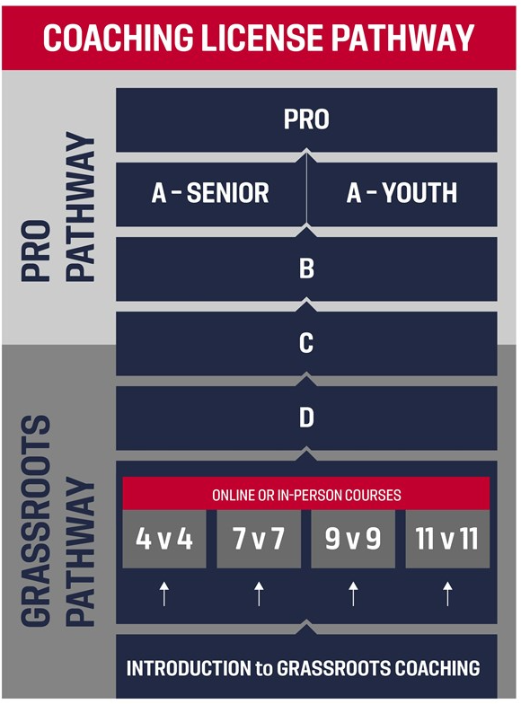
All coaches need to do the online introduction to grassroots coaching. Click Here
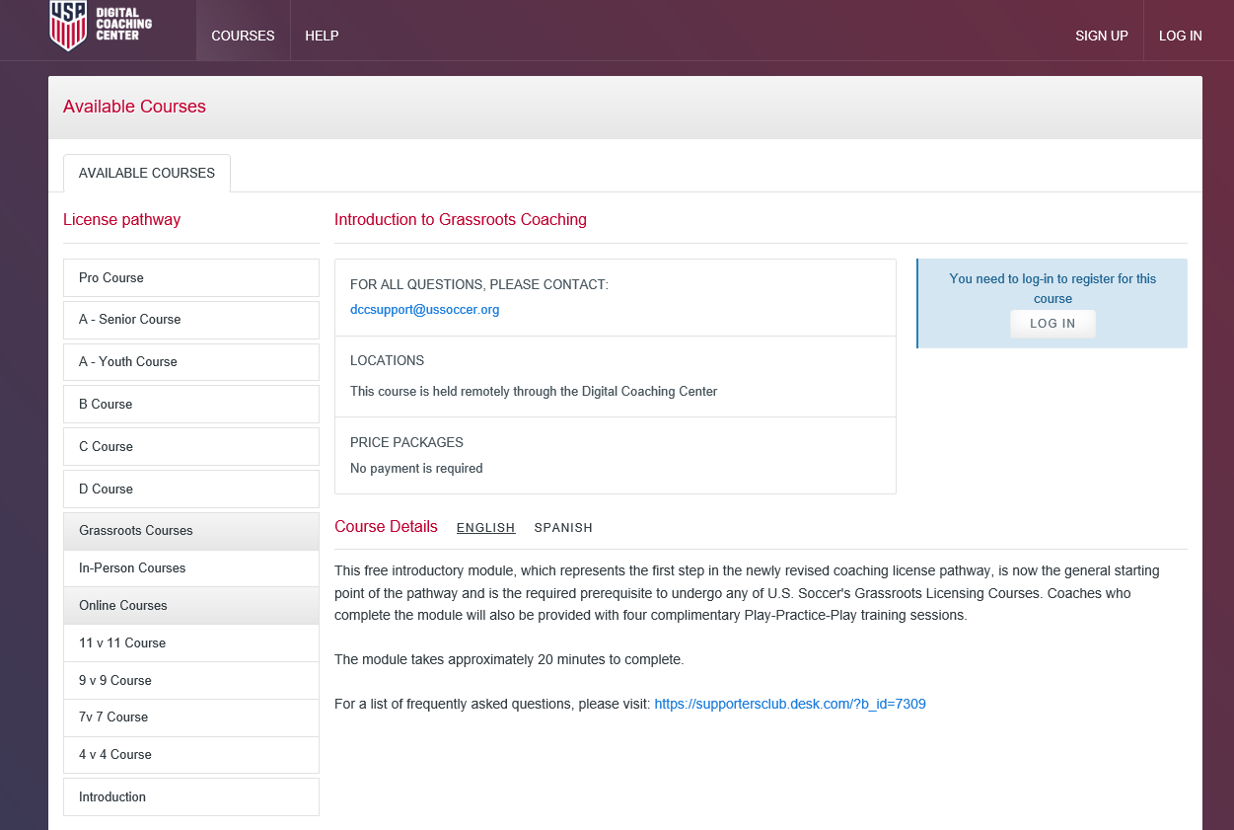
We also recommend that you take the appropriate level course for the team you are coaching.
4v4, 7v7, 9v9 or 11v11
Email to new coach.

